***Database***

**Submitted to**

**Sir Usman Ghani**

**From**

**Muhammad Soban Shami**

**S23BDOCS1M01138(2M)**

# CHAPTER 1

* 1. **Overview:**

# INTRODUCTION

UNIVERSITY MANAGEMENT SYSTEM (UMS) is a flagship product of Easy Solution which covers all aspects of Universities, Colleges or Schools. UMS covers every minute aspects of a universities work flow and integrates all processes with user friendly interface. With hundreds of satisfied customers UMS is first choice of several state, governments/semi- government universities and institutions. UMS is an outcome of hard work done by our expert technical team in supervision of several renowned educationists which includes Controller of examination, faculties. UMS is a rare combination of experience and precision. UMS streamline path of information flow in organization by taking care of following departments:

* + - Fee Department
    - Examination Department
    - Attendance
    - Faculty information portal
    - Student information portal

## Purpose:

* + - Drive operational efficiency.
    - Self-service systems with simple to use with little or no training.
    - Elimination of duplicate data entry processes.
    - Integrated with Online Application workflow with unified data model.
    - Monitoring and decision support system.
    - Automation of all the Academic / Examination / Administration operations.
    - Ease and accuracy of reporting.
  1. **Scope:**

This project deals with the various functioning in College management process. The main idea is to implement a proper process to system. In our existing system contains a many operations registration, student search, fees, attendance, exam records, performance of the student etc. All these activity takeout manually by administrator.

# CHAPTER 2

**REQUIREMENT SPECIFICATIONS**

* 1. **Software Requirements :**

Operating system : Windows 10

Application server : JAVA (NetBeans)

Front end : JAVA

Connectivity : JDBC Driver

Database connectivity : WAMP (MYSQL Console)

**REQUIREMENT ANALYSIS**

## E-R DIAGRAM:

**ER Diagram:** ER Diagram is a high-level conceptual data model diagram. Entity-Relation model is based on the notion of real-world entities and the relationship between them. ER modelling helps you to analyse data requirements systematically to produce a well-designed database.

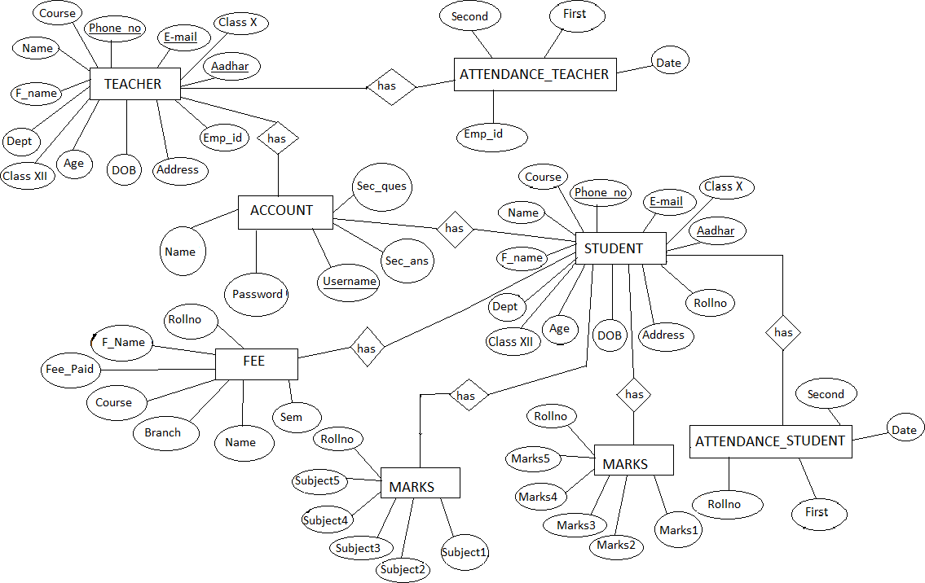

**Figure 4.1: ER Diagram for Smartphone Management Arena**

## SCHEMA DIAGRAM:

**Schema diagram** A schema diagram is the skeleton structure that represents the logical view of the entire database. It contains a descriptive detail of the database.

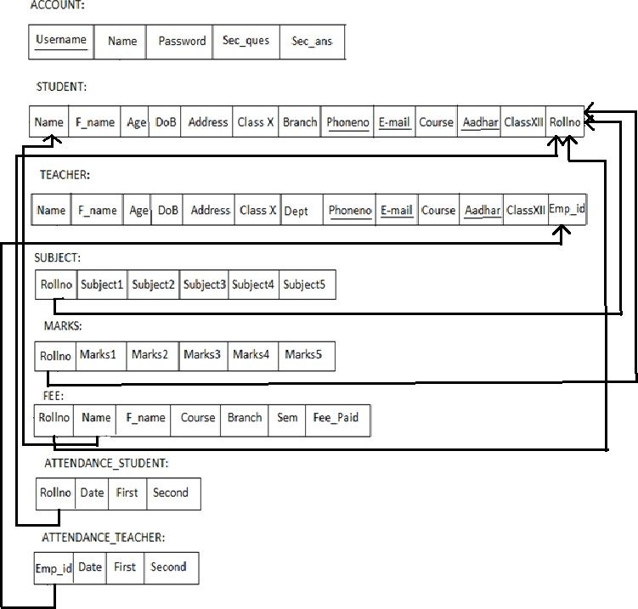

**Figure 4.2: Schema Diagram for Smartphone Management Syste**

**TESTING**

System testing is the stage of implementation, which is aimed at ensuring that the system works accurately and efficiently before live operation commences. Testing is the process of executing the program with the intent of finding errors and missing operations and also a complete verification to determine whether the objectives are met and the user requirements are satisfied. The ultimate aim is quality assurance.

## Unit Testing

The software units in a system are modules and routines that are assembled and integrated to perform a specific function. Unit testing focuses first on modules, independently of one another, to locate errors. This enables, to detect errors in coding and logic that are contained within each module. This testing includes entering data and ascertaining if the value matches to the type and size supported by java. The various controls are tested to ensure that each performs its action as required.

## Integration Testing

Data can be lost across any interface, one module can have an adverse effect on another, sub functions when combined, may not produce the desired major functions. Integration testing is a systematic testing to discover errors associated within the interface. The objective is to take unit tested modules and build a program structure. All the modules are combined and tested as a whole. Here the Server module and Client module options are integrated and tested. This testing provides the assurance that the application is well integrated functional unit with smooth transition of data.

## User Acceptance

Testing User acceptance of a system is the key factor for the success of any system. The system under consideration is tested for user acceptance by constantly keeping in touch with the system users at time of developing and making changes whenever required

**SNAPSHOTS**

1. **Login form:** This page represents the first thing about our website. It leads on to the login point for its personnel; it takes up the username,password and signup.

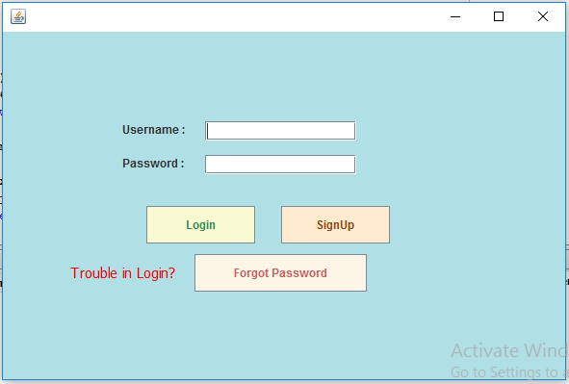

1. **Signup page:** This page represents signing up to website. It leads to registering to website making username and password, it takes the up username, name, password and security question. These information are mandatory.

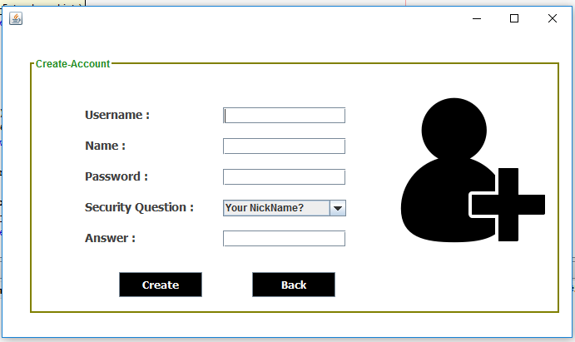

1. **Home page user :** This page shows us what user can see and access. He can add, remove,update and upload the data. He can logout from the website in homepage.



1. **Student form :** In this we can add the new student details which will be stored in back end of user.This details further can updated in the update page.

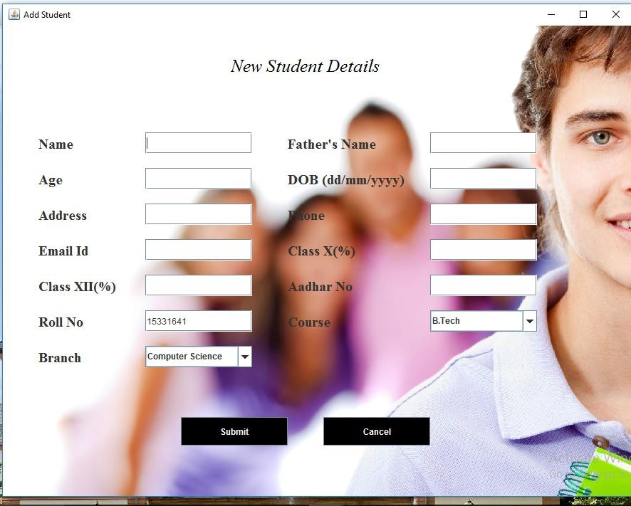

1. **Teacher form:** In this we can add the new teacher details which will be stored in back end of user.This details further can updated in the update page.

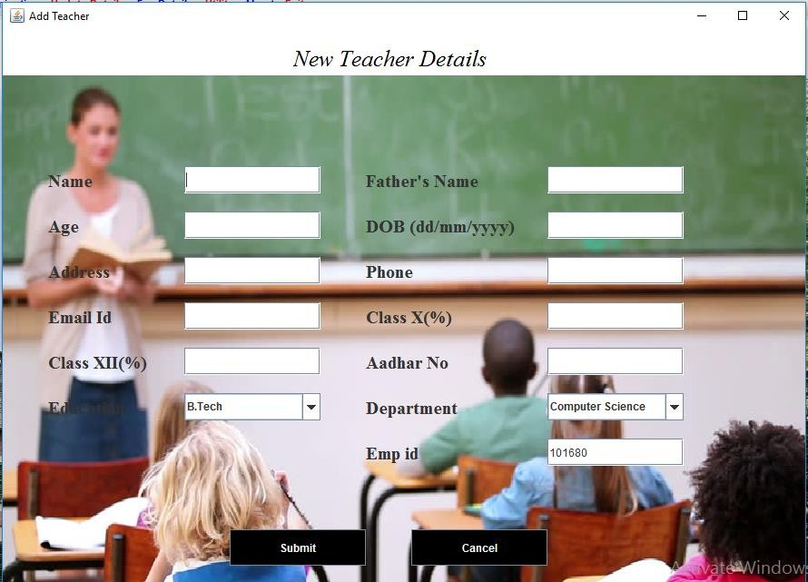

1. **Marks and Subject page :** In this page we can enter the subjects and marks scored in that particular subject along the rollno.

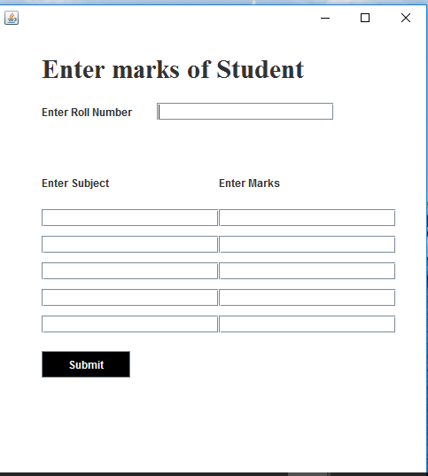

1. **Fee payment page :** In this page we can the pay the fee dues of the particular student which uses rollno,course,branch and sem to pay the fee.

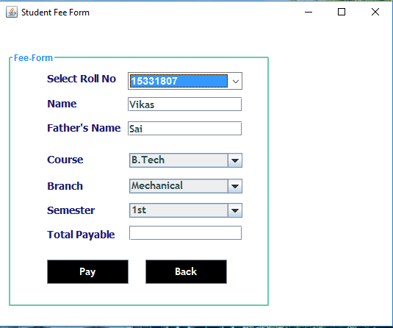

# CONCLUSION

The project entitled as **Institution Management System** is the system that deals with the issues related to a particular institution.

This project is successfully implemented with all the features mentioned in system requirements specification.

The application provides appropriate information to users according to the chosen service.

The project is designed keeping in view the day to day problems faced by a college.

Deployment of our application will certainly help the college to reduce unnecessary wastage of time in personally going to each department for some information.

Awareness and right information about any college is essential for both the development of student as well as faculty. So this serves the right purpose in achieving the desired requirements of both the communities.